LET THE COUNTDOWN BEGIN!
ALDI LAUNCHES LUXURY BEAUTY ADVENT CALENDAR
Beauty lovers rejoice, Aldi’s beauty brand, Lacura, is launching its very first luxury Advent Calendar (£54.99). Boasting a stunning look that is sure to take pride of place in any shelfie, this beauty box is packed full with twenty four iconic cruelty-free products, from cult favourites to brand-new launches.
From dermatologically tested skincare and sought-after perfumes to a pillow sleep spray, this Christmas countdown must-have is available to pre-order online from the 24th October and available in stores on 28th October, while stocks last.

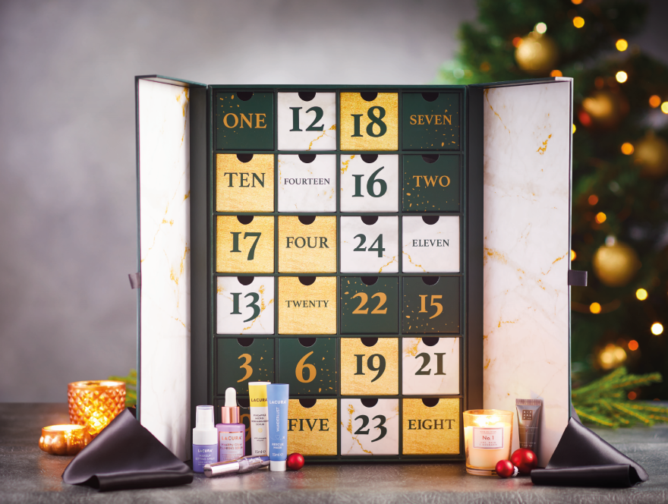

Refresh and pamper with the Lacura Ebony Rose Face Mask and Lacura Ebony Rose Cream, formulated with Black Rose Extract, Pro-Vitamin B5 and Shea Butter to leave skin feeling smooth, soft and plump. With added Vitamin B3 and Avocado Oil, the illuminating mask will help skin appear more youthful and moisturised.
Remove stubborn makeup, dirt and impurities with the Lacura Jelly Cleanser, boasting a luxurious gel that is enriched with essential oils to leave complexions soft and clean. Beauty lovers can up the ante with the Lacura Vitamin C Serum, formulated with 15% Vitamin C, E and essential fruit extracts to give skin a radiant glow from within and help combat the signs of ageing.
Those looking to work wonders overnight can improve the appearance of dullness and dark circles with the Lacura Avocado Overnight Eye Cream, formulated with coffee seed extract, retinol and avocado oil. Pucker up with the Lacura Dewy Lip Balm, packed with shea butter, coffee seed oil and aloe barbadensis leaf extract so lips remain moisturised with a hint of colour.
Not forgetting those that like a seasonal glow, the advent calendar also includes the brand-new Luxury Illuminating Tanning Drops that will take festive looks to the next level as beauty fanatics count down in style.
The Lacura Advent Calendar is available to pre-order online from the 24th October and in stores 28th October while stocks last. Please find the full list of products below:
Product
Lacura Too Legit Mascara
Lacura Brow Gel
Lacura Je Suis Belle EDP
Lacura Floral Noir et Blanc EDP
Lacura Dream Big Bronzer
Lacura Rose Micellar Water
Lacura Ebony Rose Face Mask
Lacura Ebony Rose Face Cream
Lacura Retinol & Collagen Serum
Lacura Vitamin C Serum
Lacura Luxury Illuminating Tan Drops
Lacura Wanderlust Rescue Mask
Lacura Make-up Setting Spray
Lacura Cleansing Balm
Lacura Pillow Spray
Lacura Avocado Eye Cream
Lacura Glow Vitamin C Oil
Lacura Hemp Hand Cream
Lacura Microdermabrasion Scrub
Lacura Jelly Cleanser
Lacura Dewy Lip Balm
Lacura Foundation Primer
Rose Noir Candle
Night Orchid Candle

-ENDS-
For further information, images or to request a sample, please contact the Aldi press team on:
alditeam@clarioncomms.co.uk
020 7479 0910
www.facebook.com/AldiUK
www.twitter.com/AldiUK
www.instagram.com/AldiUk
Please contact the Aldi team at Clarion to confirm product details and availability prior to print.

